Setup Guide

Here’s how to install the modpack and connect to the Honorables minecraft server.
If you have any additional questions or need additional help, email me at sterlingmccrevey11@gmail.com.

This is a manual modding guide. We will not use CurseForge or any other modding softwares to assist in the process as the modpack for this server is completely CUSTOM.

I am going to assume for the remainder of this guide that you have access to the Google Drive, as you are reading this document.

Join the discord: https://discord.gg/HGaf7zcNCQ

Step 1: Getting Minecraft
Ensure you have the latest minecraft launcher.

Visit the minecraft official site to get it if you do not already have the game.
https://www.minecraft.net/en-us/download

The version of minecraft we are using is Java Edition. Bedrock will not work.

Once you have the launcher, after running the installer, you must sign in to your microsoft account.

Sign in using the ACCOUNT YOU OWN THE GAME ON, not your school account!

Then, and only then, will the launcher look like this (if you own the game).
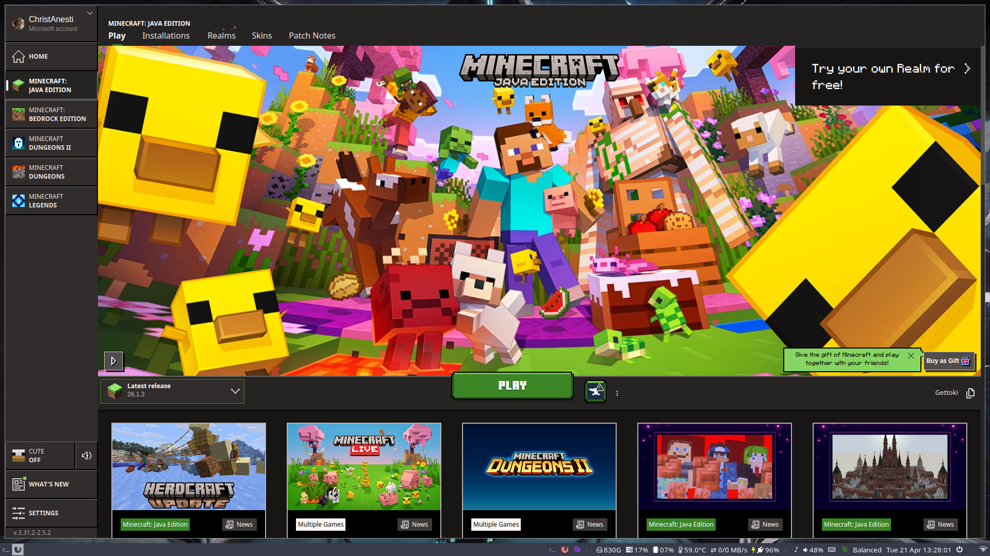

If you do not yet own Java Minecraft, you can purchase it through the launcher by selecting Java Minecraft on the left side bar.

Step 2: Getting Forge

Now that you have a licensed version of minecraft running on your computer, we can now install minecraft forge 1.16.5.

Minecraft forge is the modloader that compiles the mods we are using on the server, allowing us to modify the game.

** IF YOU DO NOT INSTALL THE PROPER VERSION OF FORGE, YOU WILL NOT BE ABLE TO CONNECT TO THE SERVER **

Forge is version specific and each forge version corresponds to the appropriate version of minecraft we choose to play on.

This server runs on Minecraft 1.16.5.

To get the version of forge you need, go to the Google Drive I gave you access to, the one that houses this document, and download the file titled: forge-1.16.5-36.2.42-installer.jar.

Make sure you close your launcher to install Forge. If you don’t close it, you will have to restart it after the installation of Forge is complete.

Once the installer is on your computer, locate the file (it is probably in your Downloads folder) and double click the program to execute it.

If everything is working properly, you should see this screen popup:
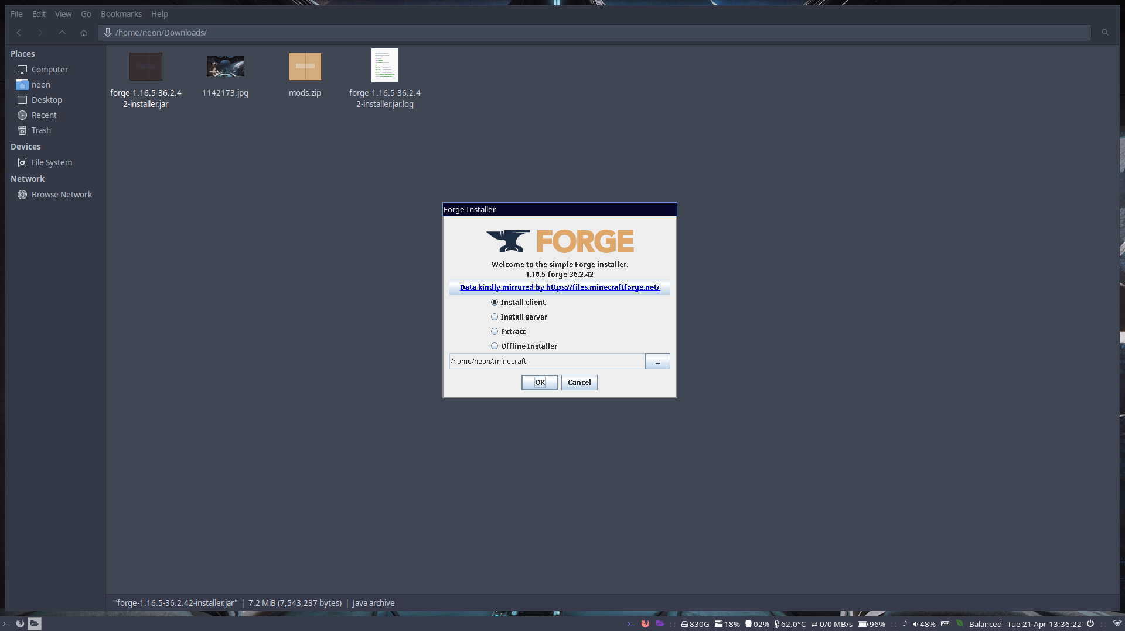
Make sure the Install client option is checked.

I also recommend that you copy the directory listed in the text box below the radial buttons. In my case it reads: /home/neon/.minecraft, but on Windows, is most likely reads: C:\Users\*your username*\AppData\Roaming\.minecraft.

Make sure you save this directory. We will be needing it later.

Now, on the installer, once you have selected “Install client”, and have verified that the minecraft folder is correct, click “OK” and wait for the installer to finish.

Step 3: Verifying Forge Installation

Once the installer is done, we must verify that it has been installed correctly.

Launch your minecraft launcher again. If you did not close it while the installer was running, restart the program to reflect the recent changes.

Your launcher should look like this:
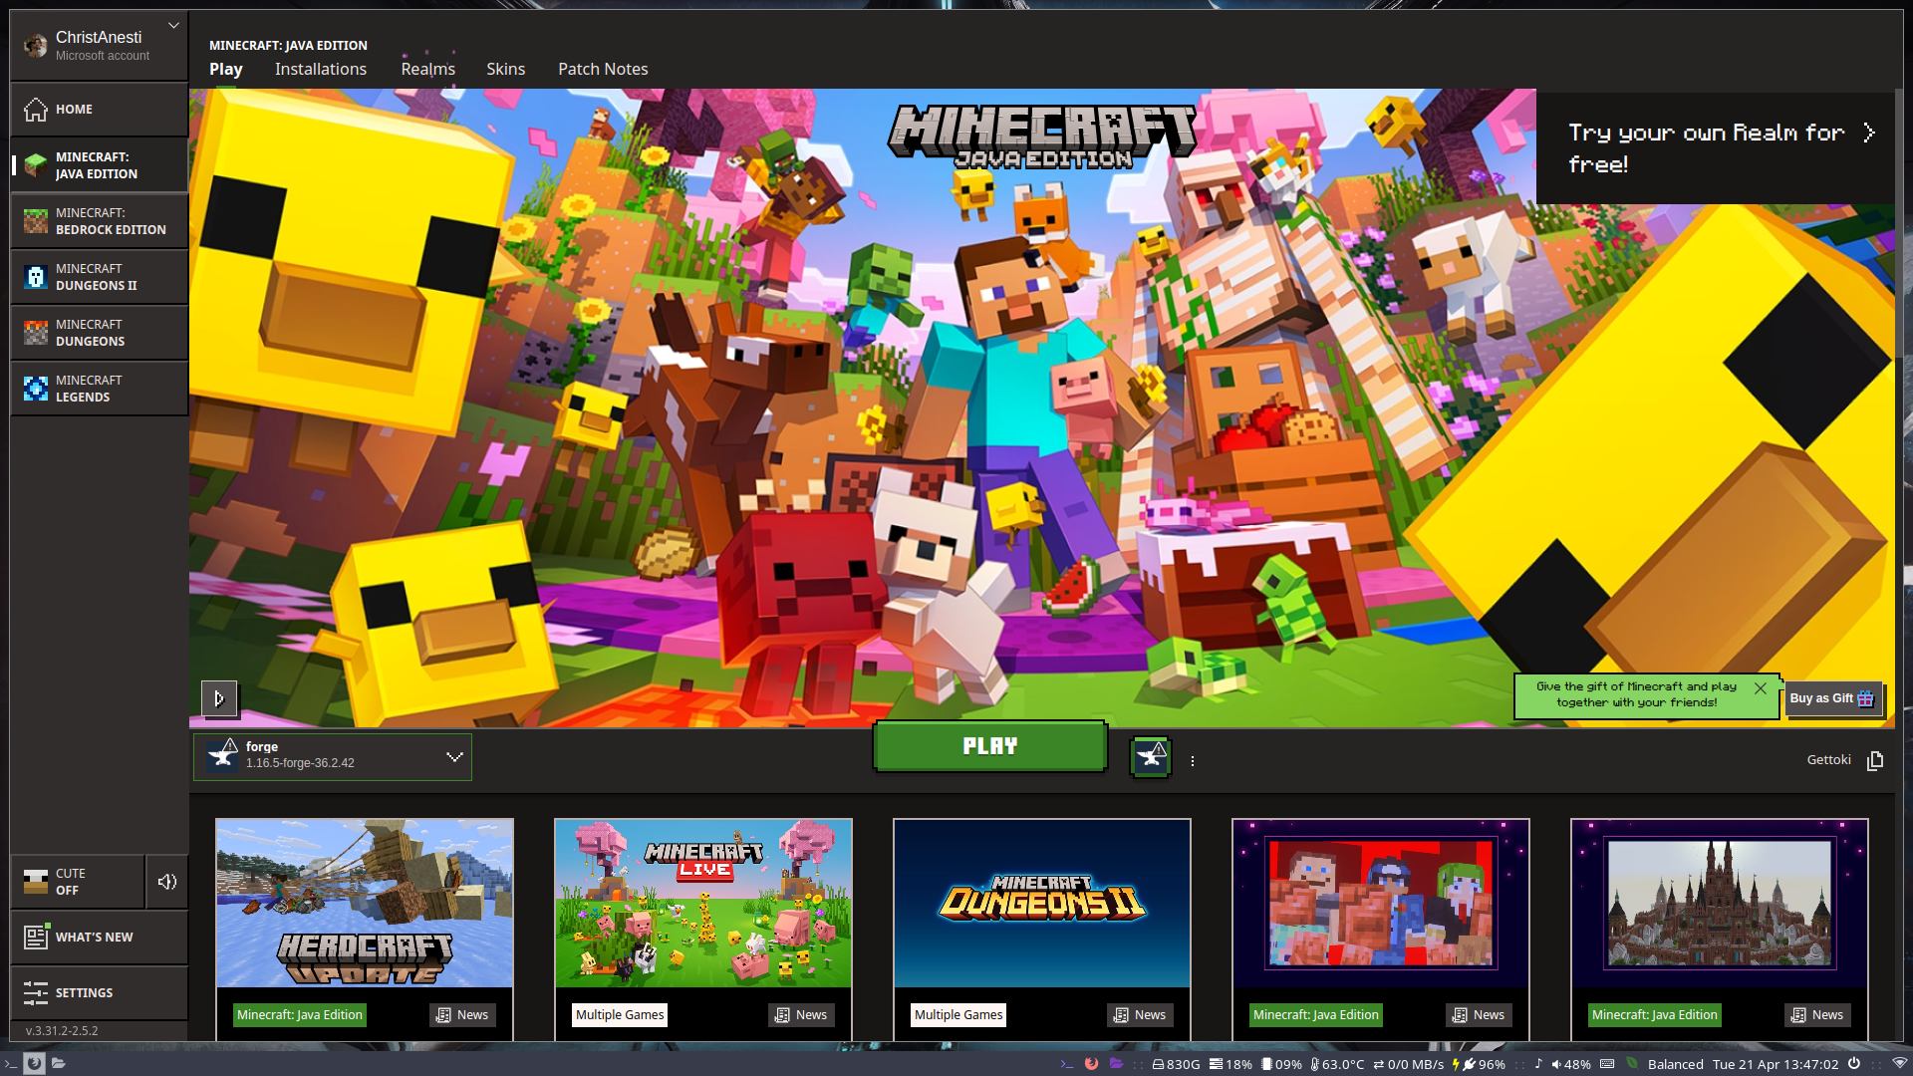

Now, left of the play button you should see either “forge” or “Latest release”.

Select from the drop down: “forge.

Now, if there is no forge option, we will have to manually add a new instance.

Click on the “installations” tab on the top toolbar. The screen should look like this: 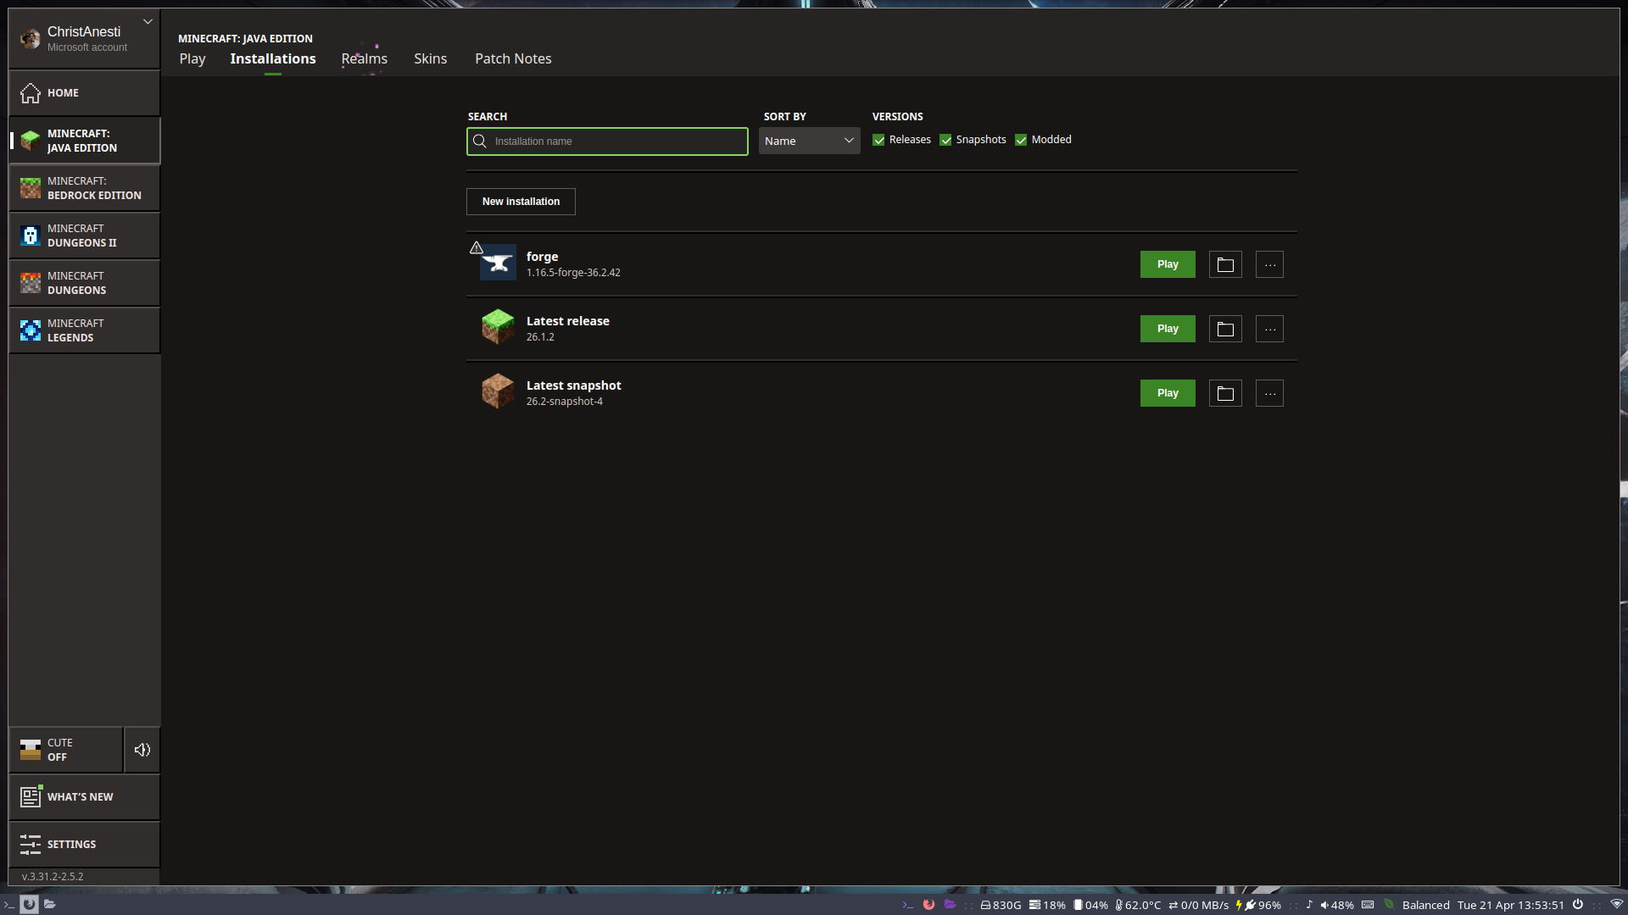

If the appropriate forge version is there, skip to step 4.

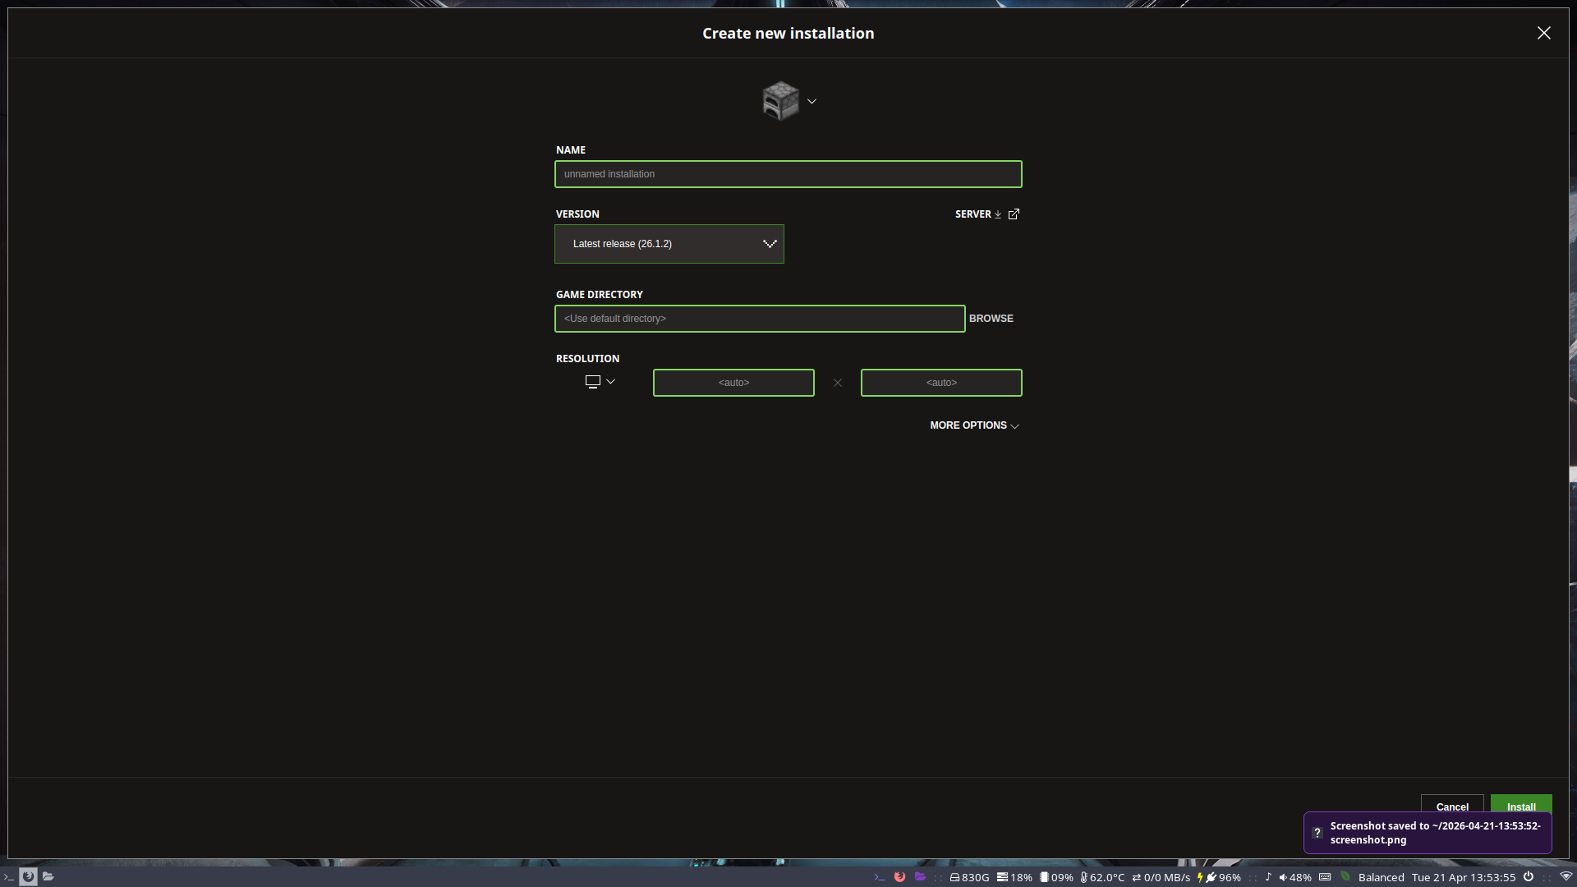
Now, click the button that says: “New Installation.” A new menu should pop up.
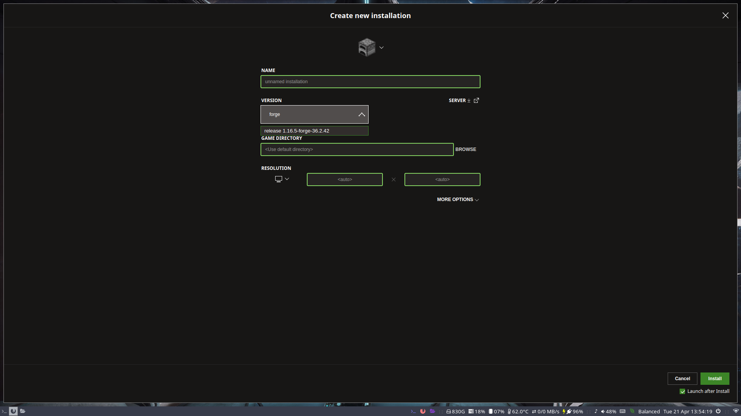
Click the “Version” dropdown and search “forge”.
Select version 1.16.5.
Then click “install” at the very bottom of the page. The installation should run. Allow it. Then close the game once it has reached the main menu of the game.

Step 4: Setting Up Forge
Now that Forge is installed, we must run the game to initialize the files and folders for our game.

** If you have installed a new instance in Step 3 and have launched Forge already, you can skip to Step 5. **

Go back to the main screen for the launcher.

Ensure that the proper forge installation is selected in the versions box in the bottom left.

Then click play.

The screen should look like this for a moment:

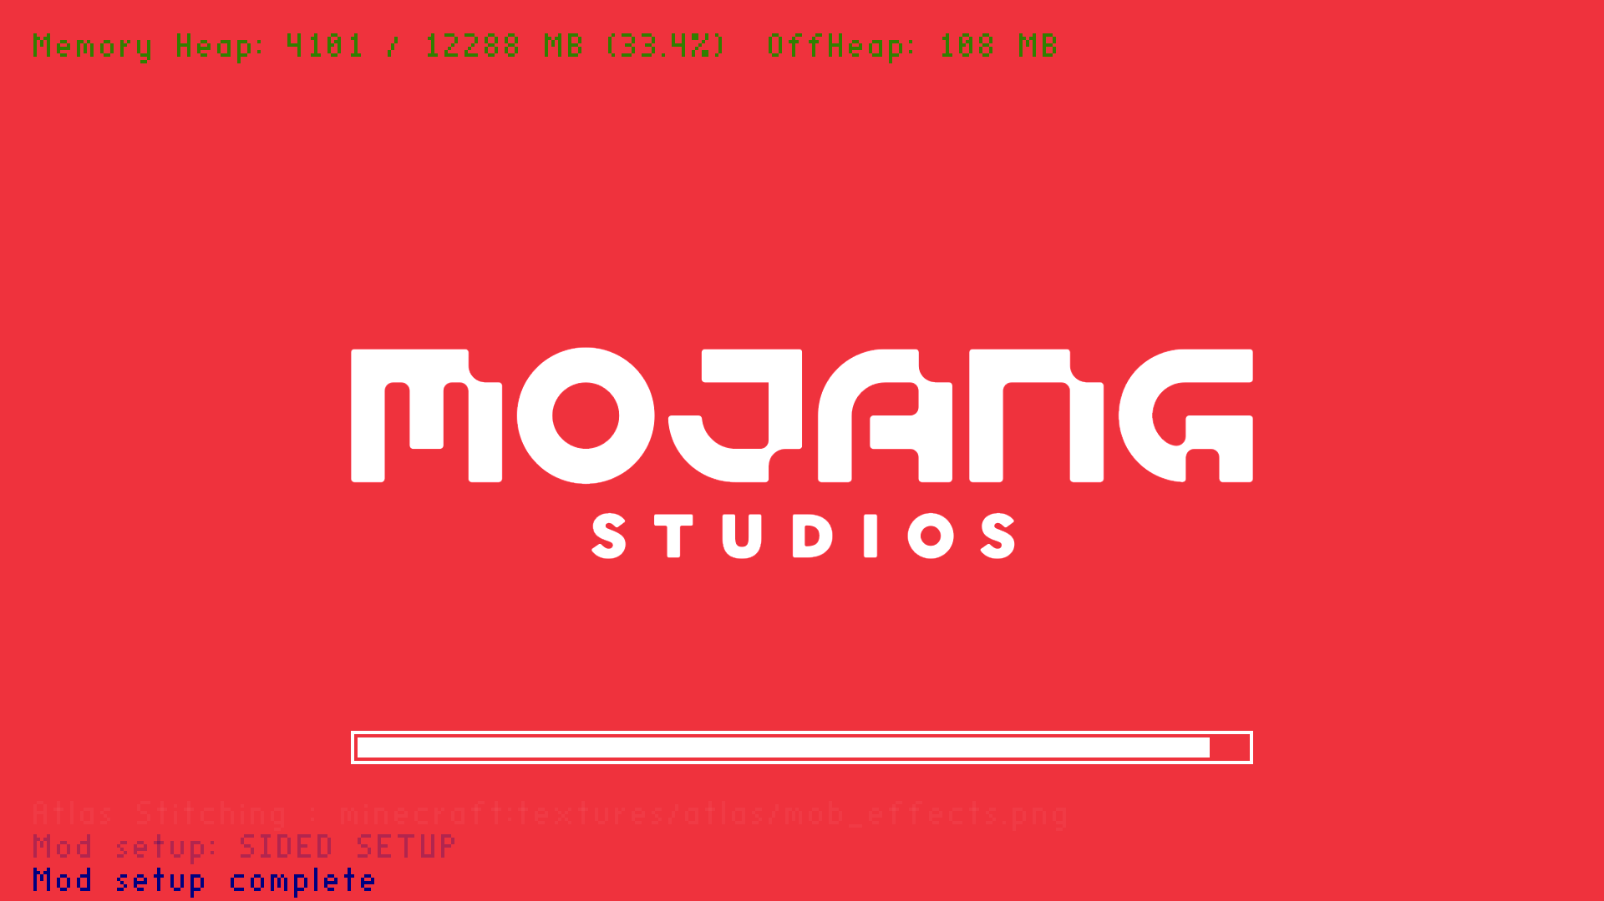

Wait for the game to compile. Do not attempt to close the game at this stage.

You can close the game once you see the menu: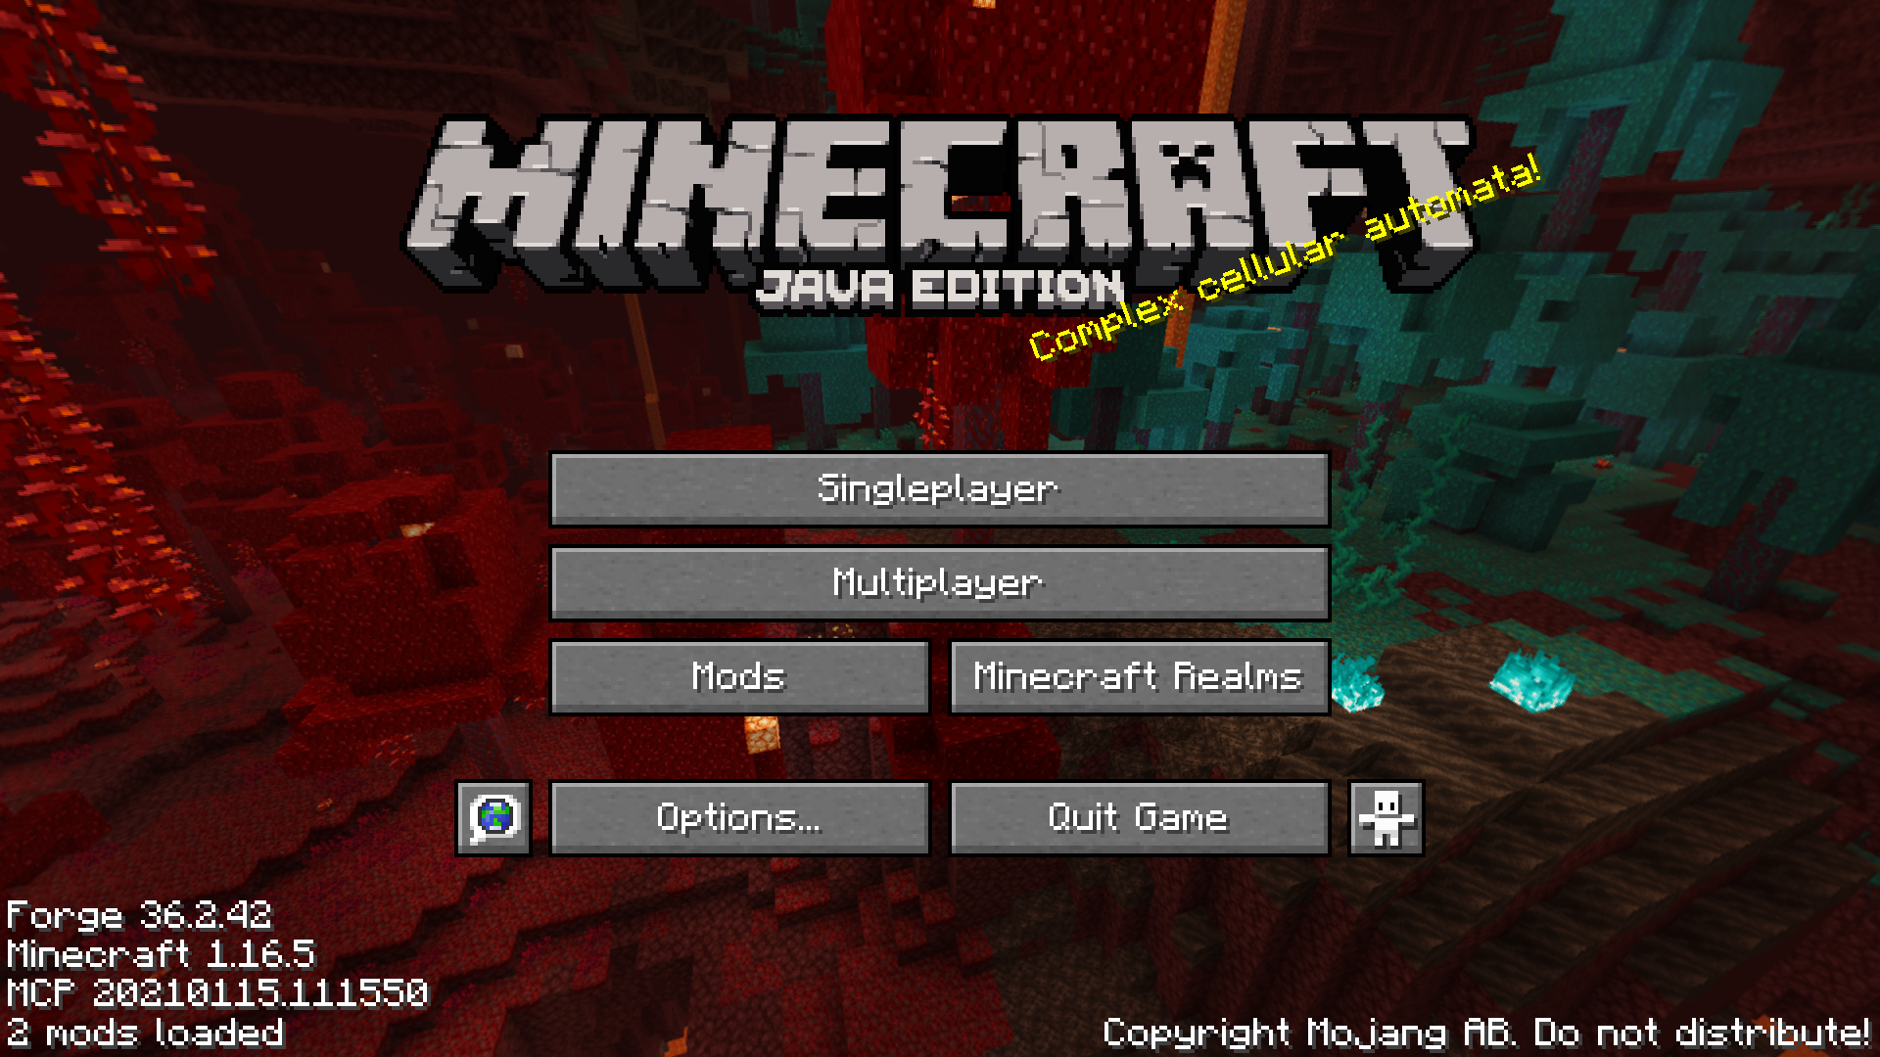
You have successfully installed and set up forge.

Now it is time to install the mods.

Step 5: Installing the Mods

The mods have been provided in the Google Drive. Download the zip file called “mods.zip.”

Now we must find the installation directory of the mods folder for our minecraft version.

Go into the “Installations” page in the minecraft launcher. It should look like this:

Click on the folder icon. Copy the path of the folder and extract the mods to it.

Make sure your mods.zip archive extracts into the root folder of the installation. The mods will NOT load if they are not in the mods folder.

Verify the mods have been extracted into the “mods” folder inside your game installation (the path to your forge installation should be something like: “C:\Users\your username\AppData\Roaming\.minecraft\versions\1.16.5 forge”).

Your mods folder should look something like this:
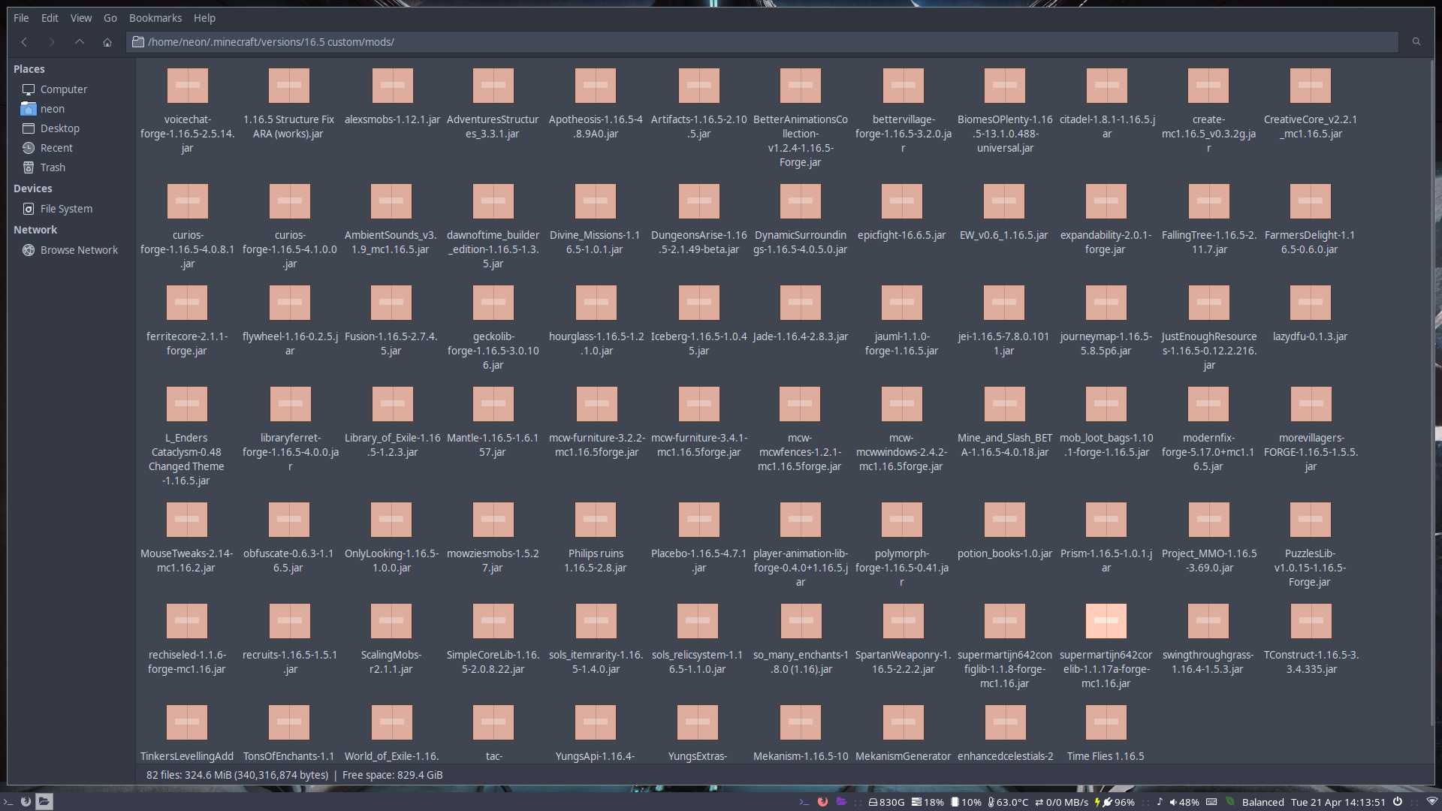

This is my file path to my mod folder. Note that this will not look like yours because I am on Linux and you are probably on windows.

Step 6: Editing the Installation

Now, go back to the previous window, the Installations section, and click the 3 dot icon next to the forge version.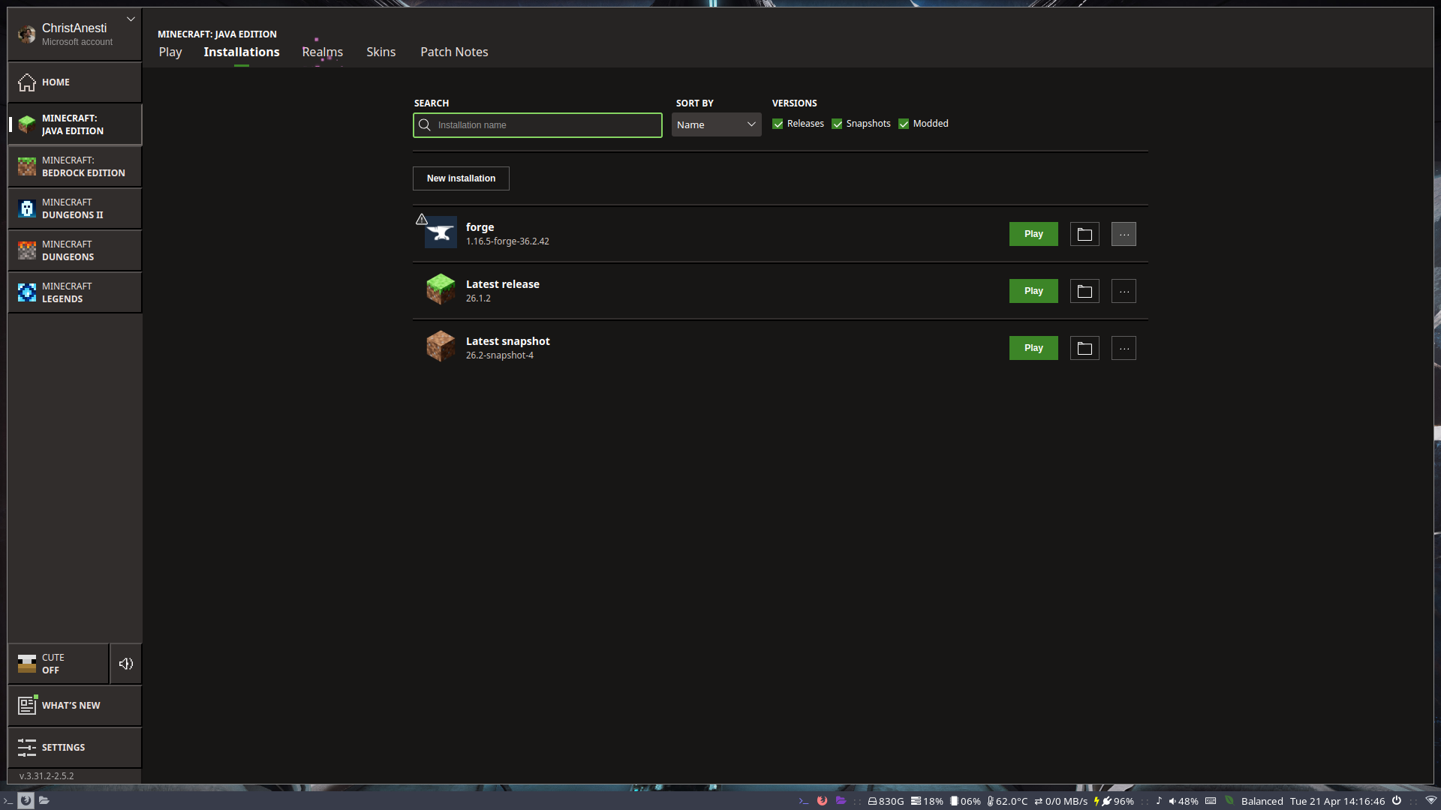

Then click “Edit.”

A new window should popup, allowing you to modify the installation.

There is only one thing we are changing and this is under the “More Options” button at the bottom. Click it.

You should see this:
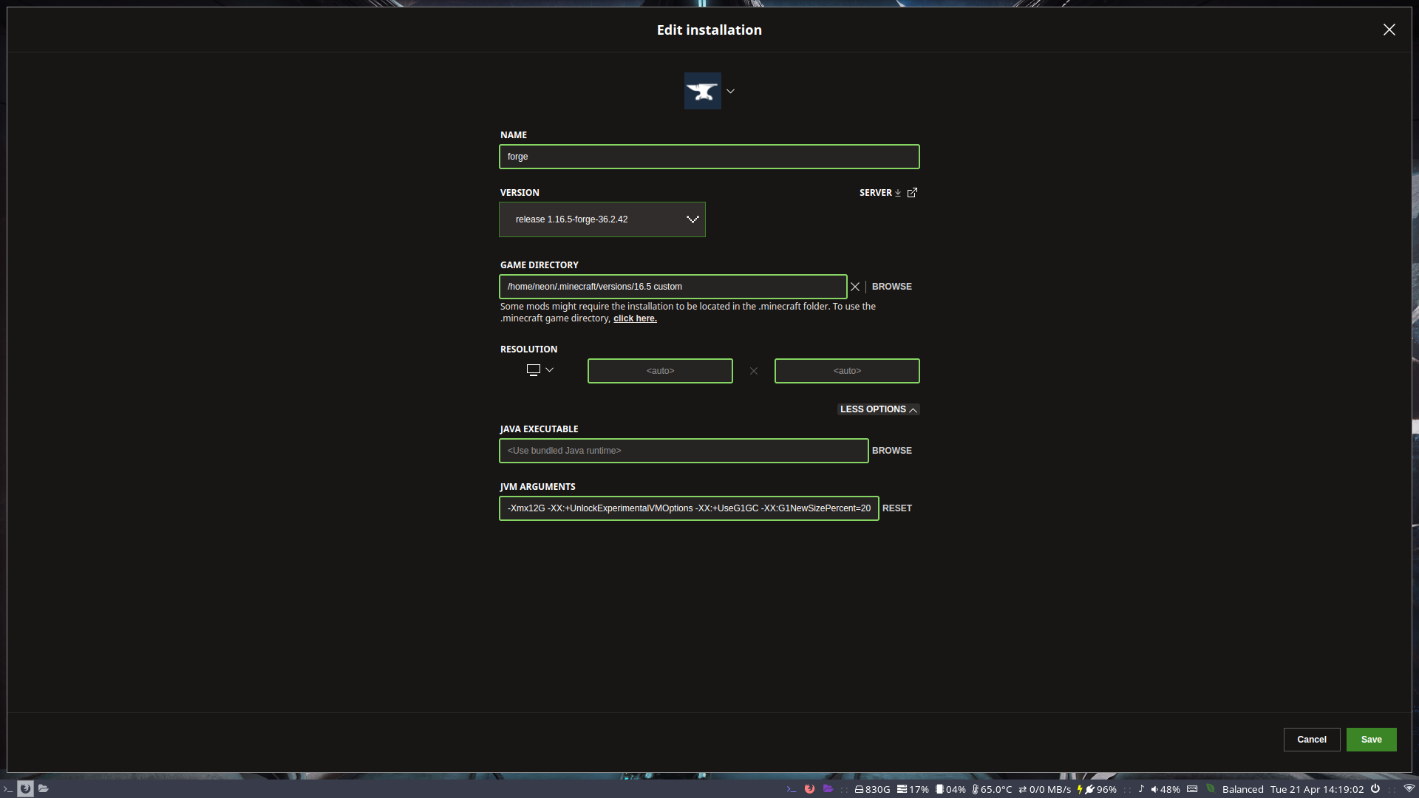

We are going to exit the Java Arguments at the bottom and increase the amount of memory the game is allowed to have.

Depending on your memory capabilities, how much RAM your computer has, 2 gigabytes might be enough, it is the default. But, you can allot more ram by changing the section here: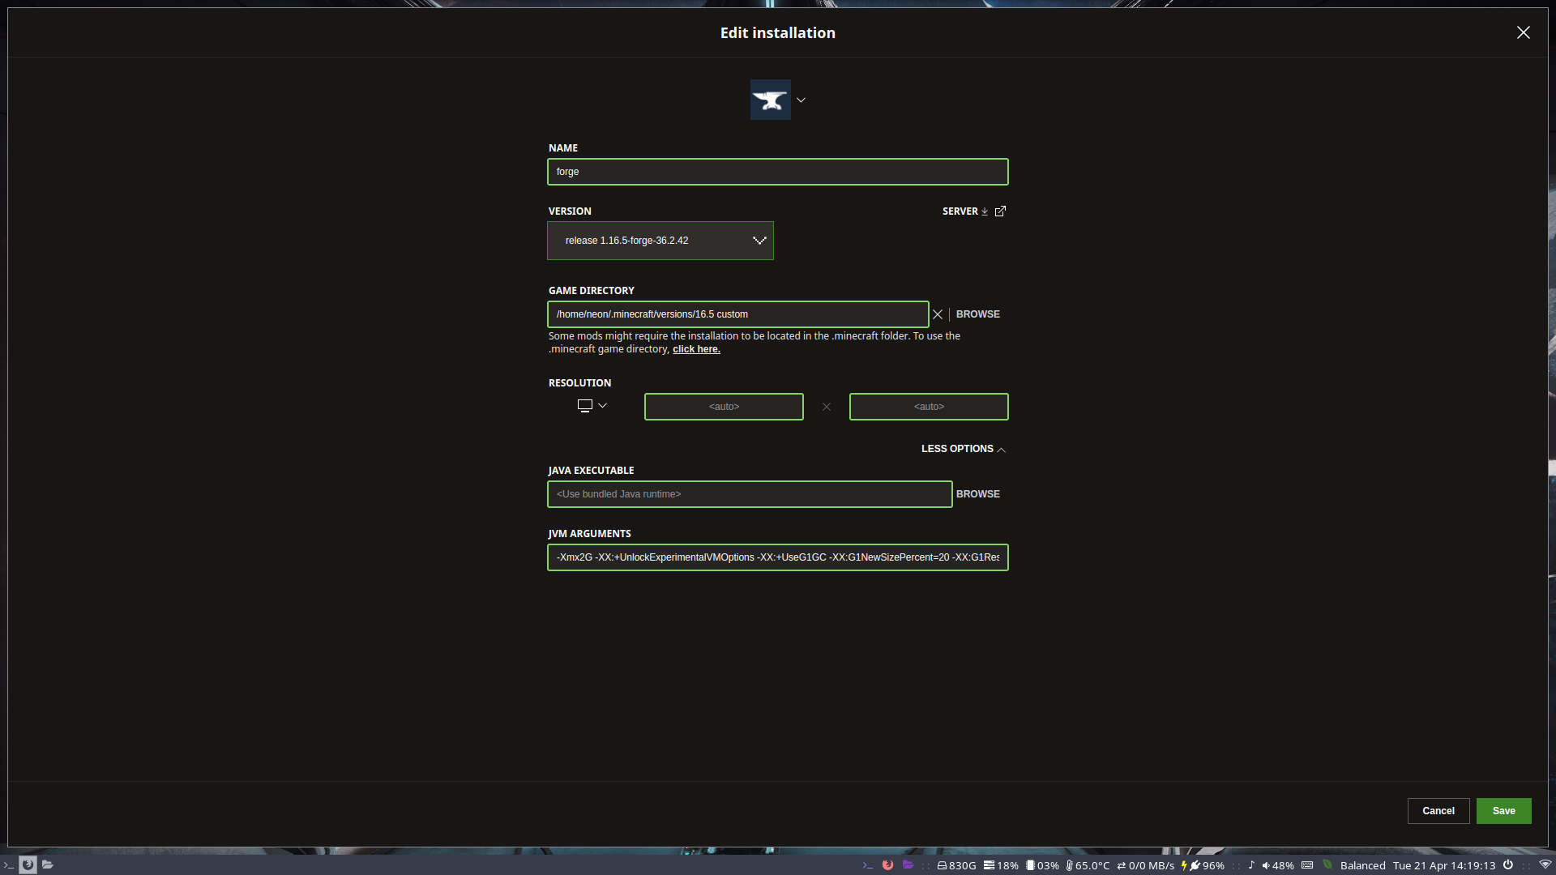
Change the 2 in “-Xmx2G” to any number of gigabytes you want to allocate. In my case, I changed it to 12G.

Once you have done this, you are ready to load the modpack and try to connect to the server.

Step 7: Compiling the Modded Game

Go back to the installer main page and click the “play” button.

Again, you should see the red splash screen, but it should take a little longer.

If the game successfully loads to the title screen, check the bottom left corner to ensure all the mods loaded properly. It should say something like 80 mods loaded. This number will vary because I am constantly adding and removing mods, but it should be more than 2 mods.

If the game says there are only two mods loaded, you did not install the mods correctly, meaning you must go back to step 5.

If the mods are not the exact same on your minecraft installation as they are on the server, the server will reject your connection.

Here you can see the number of mods loaded on my installation in the menu:
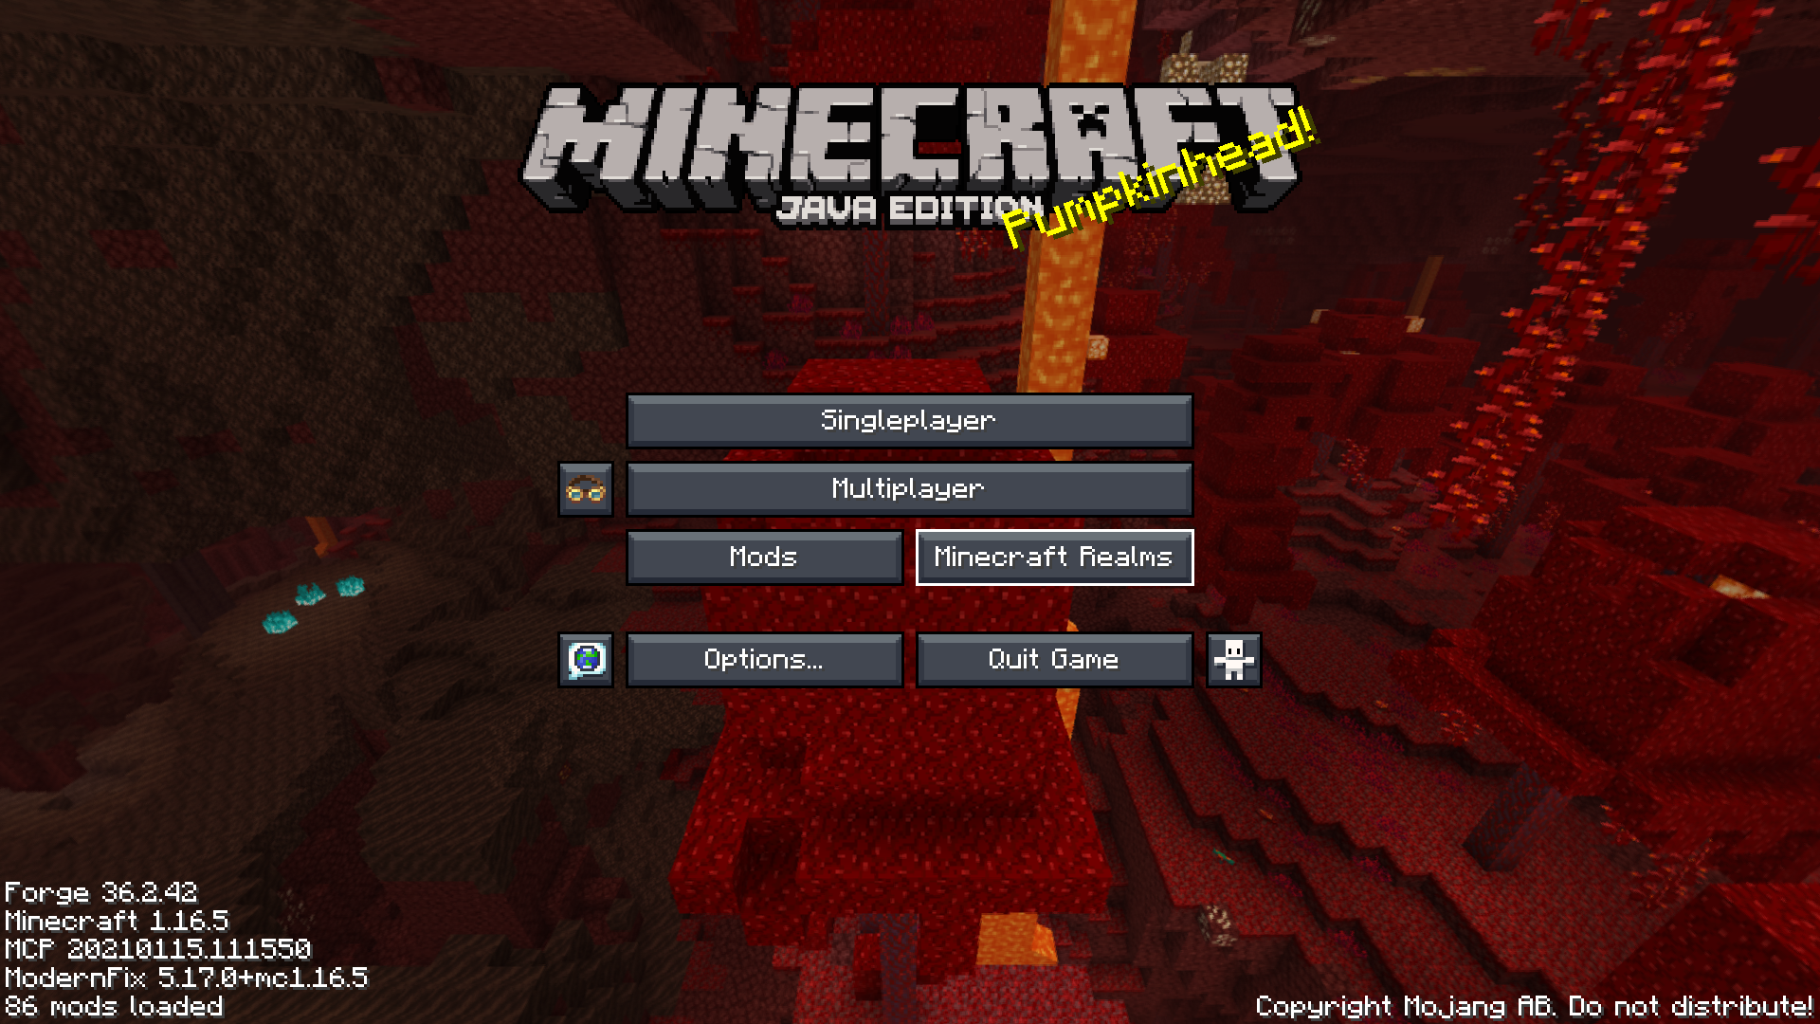

Note how many mods are loaded here. A blank forge install will have about 2 mods.
If the number of mods installed is not more than 40-50, depending on the size of the mod pack, then you must go back to step 5.

Step 8: Connecting to the Server

Now you are ready to finally connect to the server, given that you followed all the steps and verified your installations.

If everything went smoothly, you should have no problem loading in.

The server ip address is listed in a text file inside the Google drive. As of writing, the address is:

honorables.dat.gg

From the minecraft menu, click the “multiplayer” button.

The game should now look like this:
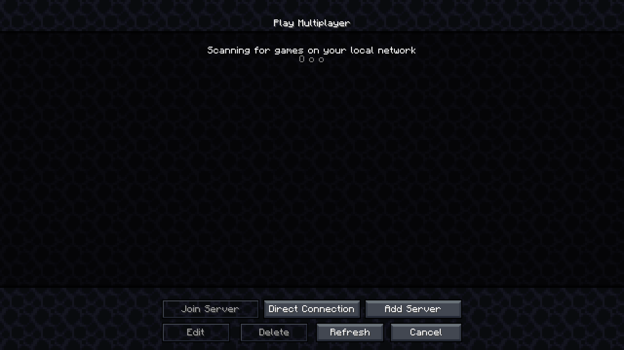
Now, you will click the “Add Server” button on the bottom tool bar.

The next window will look like this: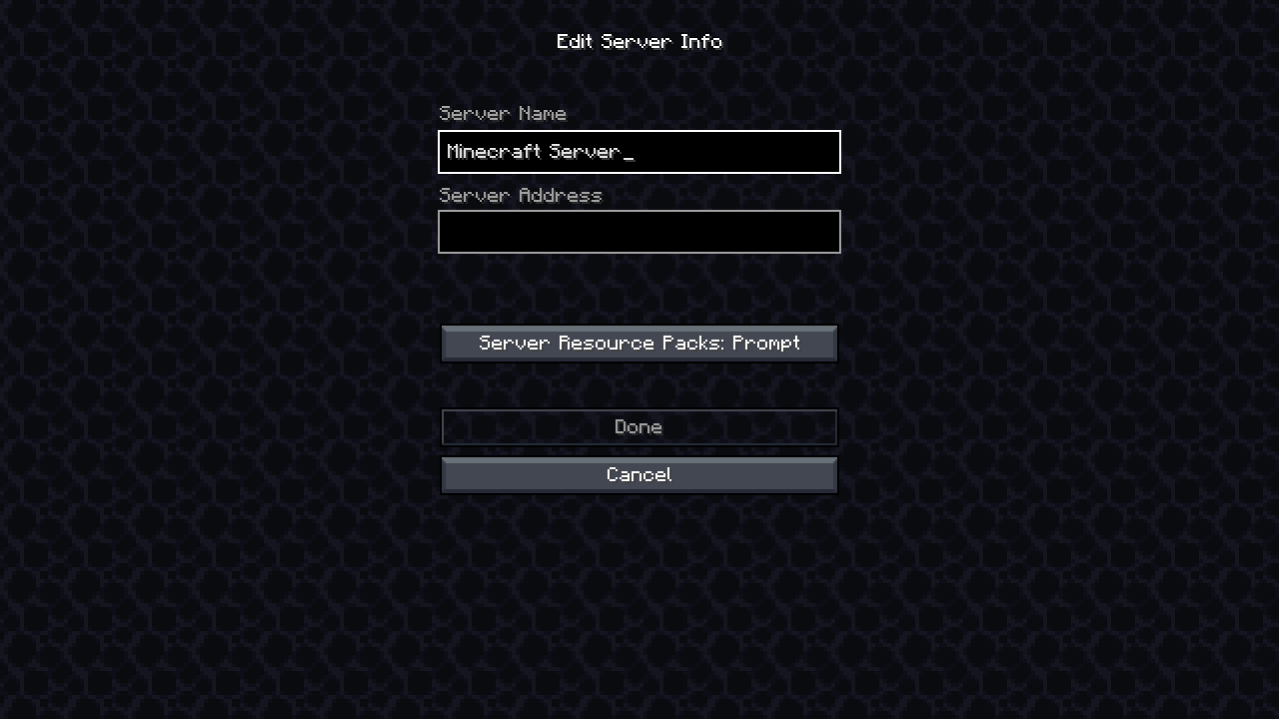
You can enter whatever name you want to call the server in the “Server Name” box, but make sure to put the address above (honorables.dat.gg) in the box labeled “Server Address.” No port specification is necessary.

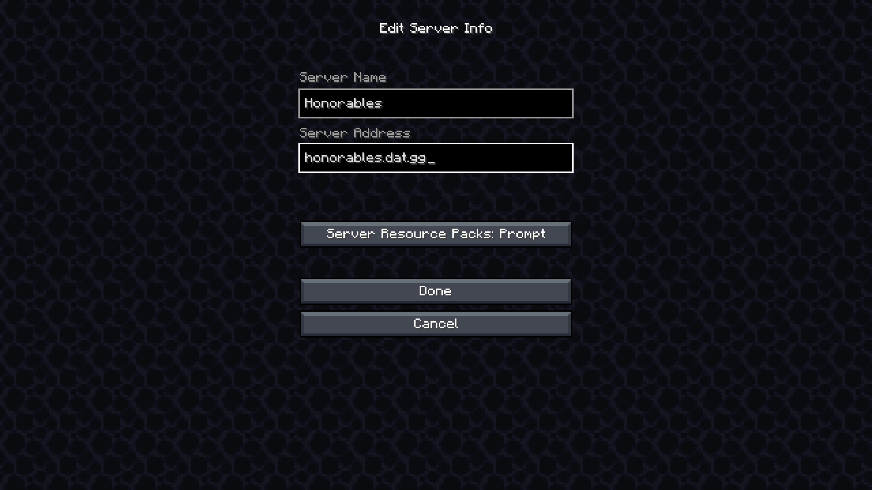
In my case, my screen looks like this:
Lastly, you will click the “Done” button, and then the server should have appeared on the list.
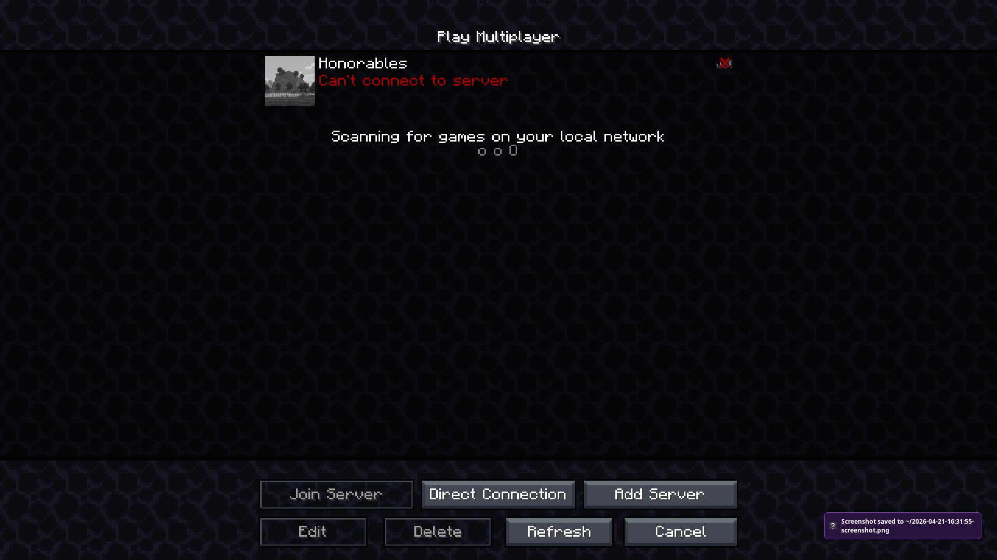
To connect to the server, simply click on the image or select it and click “Join Server” at the bottom.

If everything was set up properly, and if the server is running, then you should be able to connect with no issue!

Have fun!

Common Errors:
Below are some common errors encountered in this long process.

- The server edition of Forge is installed instead of the client version
- The Forge version installed is incorrect (this should not be the case if you installed the forge version on Google Drive)
- The mods were placed in the wrong folder upon extraction
- You allocated too much memory to the minecraft instance.
- The modpack is broken (and shows compilation errors).
- The modpack is different on your device than it is on the server.
- The server rejects connection due to a timeout.

One:
The server edition of Forge is installed instead of the client edition.

You must close your Minecraft Launcher and re-run the Forge installer that you downloaded from the Google Drive. Then MAKE SURE the “Install client” box is checked and not the “Install server.”
Then you must continue on from step 3.

Two:
The Forge version installed is incorrect.

This means you installed a Forge version for a different version of Minecraft.

The Forge version we are hosting the server on is for minecraft 1.16.5. Verify the forge installer is of the same minecraft version, and then install Forge by following the steps in Step 2.

If, for some reason, the version of forge in the Google Drive is insufficient, below is the download link for the same version of Forge from the official website:

https://adfoc.us/serve/sitelinks/?id=271228&url=https://maven.minecraftforge.net/net/minecraftforge/forge/1.16.5-36.2.42/forge-1.16.5-36.2.42-installer.jar

Install this if the fix above did not work for you and go back to Step 2.

Three:
The mods were extracted into the wrong folder.

You must ensure the mods are in the “mods” folder of the 1.16.5 installation of minecraft.

If you do not know where that is, you can locate it in Step 5.

Commonly, extraction tools create a new folder for the contents to be put in, meaning sometimes, if you extract mods.zip to your minecraft mods folder, a new folder called mods will be created inside the pre-existing mods folder. This will not work properly and is very common.

Basically: your mods folder has another folder called mods in it containing the files extracted froim the archive.

To fix this, simply move the inner mods folder into the main installation folder, the one containing the outside mods folder, and merge them. Overwrite if needed.

The file path should go from:

…/.minecraft/versions/1.16.5/mods/mods/
to
…/.minecraft/versions/1.16.5/mods

The second “mods” folder should be merged into the first.

Then simply continue from Step 6.

Four:
You allocated too much memory to the minecraft instance.

If you did this, it happened here:


You need to change the argument back to a reasonable number for you computer hardware.

Change the 2G or whatever number you put after -Xmx… back to something reasonable. 2G is fine. I would recommend 4G, so: “-Xmx4G” would be the new argument.

Five:
If the modpack is broken.

This will be obvious to you of, upon running the game, you never see the title screen and instead see a list of requirements.

If this is the case, please send me a screenshot of this page so I can fix it promptly.

Contact me at sterlingmccrevey11@gmail.com

Six:
The modpack on your local machine is different from the server.

It looks something like this: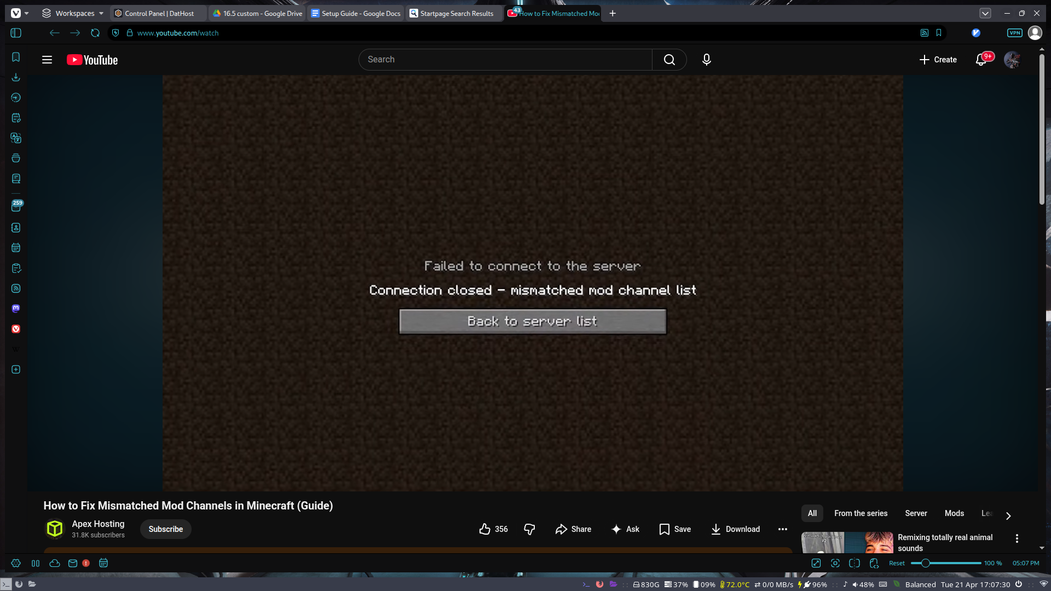

If you get this message, then you installed the wrong modlist or installed them incorrectly. Verify that you have the correct mods.zip archive installed from the Google Drive and ensure it is the latest version. Once you have repeated step 5, try to connect again.

Seven:
The server rejects your connection due to a timeout.

You probably received an error that looks like this:
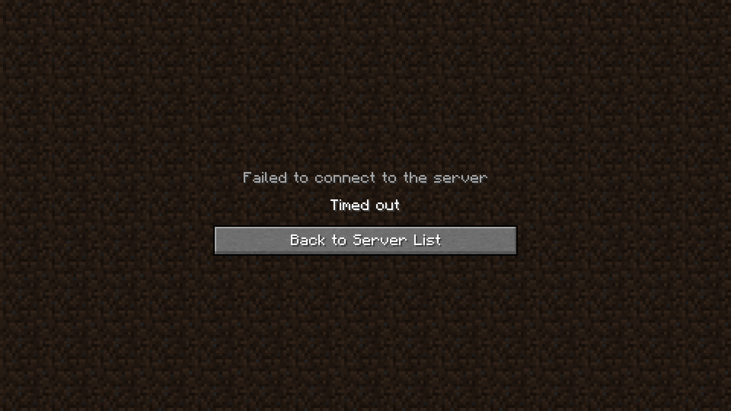
This can mean a few things, but two of them are the most common.

- Go back to Step 8 and ensure you have the proper server address.

The server list looks like this:
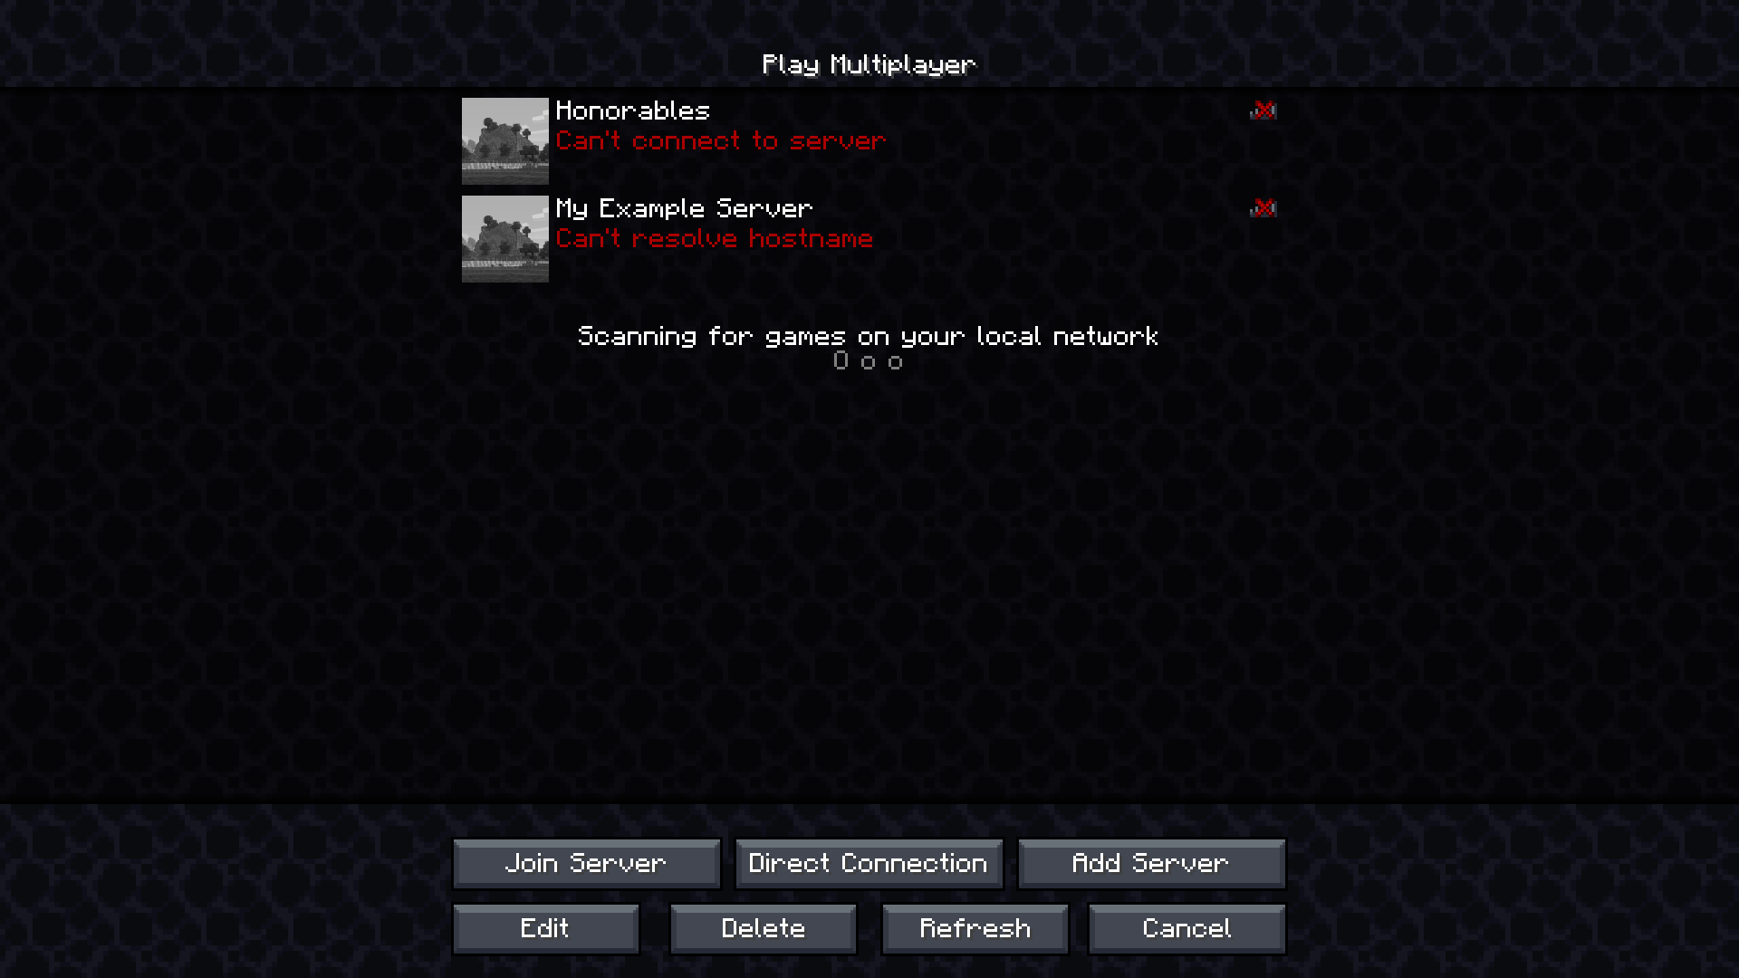
If it says “can’t resolve hostname” then you probably typed something wrong and you should double check the server address.

- The server is offline and you should wait until it is back up.
This is the more boring option, meaning I turned the server off. You won’t be able to join until the server comes back online.

If the server is offline and is rejecting your connection, it should look like this:
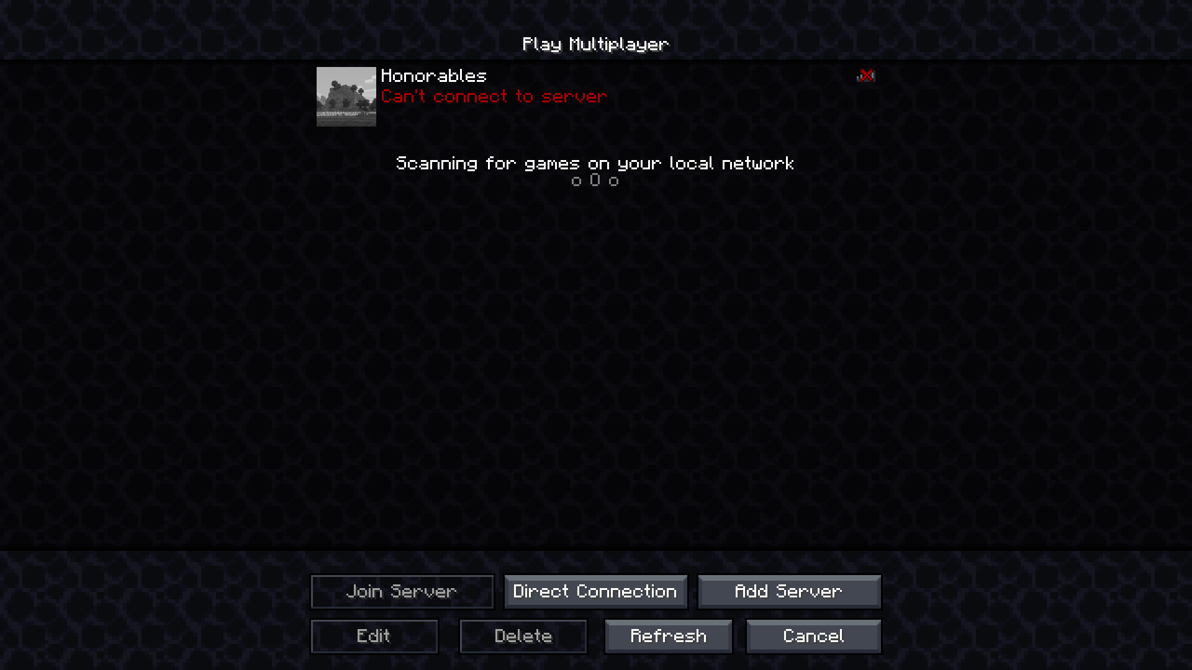
This means that the server address is reachable, but there is no connection open.

The boring answer for this circumstance is to wait, or email me.

If the server is down mid-day, as it probably should not be, contact me immediately at sterlingmccrevey11@gmail.com

Fixing Additional Issues

If you have any additional issues, please send your issue description in the bug-reports channel in the discord.

